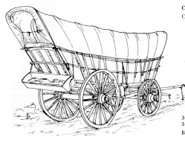
Your REAL name: ____________________________________________________ Hour: __________
Your character name: __________________________________ Nation of Origin: _______________
Push Factors: ___________________________________ Pull Factors: ___________________________________
Directions: Refer to the list of supplies posted on the board and select what you would like to take along your journey with you. All families will begin with $80 and you are able to carry your family body weight plus no more than 1,000 pounds.
Supply | # of lbs | Cost | Supply | # of lbs | Cost
Total # of lbs. ________/ 1, 000 Total money spent on supplies: ___________ Money left for the journey:__________
Week | Starting balance | Amount of Money earned or lost (+/-) | Days Ahead/Behind (+/-)
1 | $
2 | $
3 | $

