Procedure:

- Choose a group of four classmates that you will work with to research and complete the project.

Group Members: ______________________________ _____________________________________
______________________________ _____________________________________

2. You and your group will select a marginalized/minority group to research examples of inequality, conflict, and change that they experienced within the United States. You will also research the current status of this group and the inequalities/conflicts/changes they still experience today. All of your research will be recorded in your group’s graphic organizer.

3. You will create a triangle poster that will serve as a visual aide to the presentation you give to the class about your minority group. You will teach the class about the inequality, conflicts, changes, and current status of your marginalized group.

Breakdown:
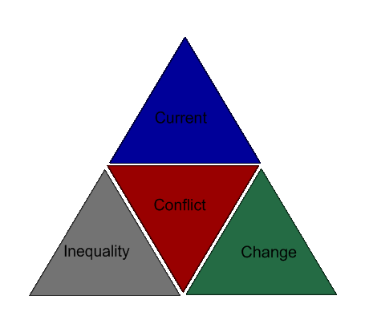
Inequality: Find out what inequalities your group has experienced. These could be social, political, or economic inequalities. Determine what ideas are behind this inequality (Why is this group treated this way?)

Conflict: What conflicts (violent/non-violent) has your minority experienced? What tactics have they used to fight against their inequality (i.e. sit-ins, protests, riots, marches, etc.)

Change: What change (positive/negative) has come from your minority group’s conflicts? Changes can be laws, a shift in attitudes, and/or political changes. You should explain the impact/effects that this change has brought on for your minority.

Current Status: What is happening with your minority group today? Do inequalities still exist? Are conflicts currently going on? What goals for change does your minority still have?

Your group must be ready to present your project on Oct. 31 ________, 2012.

Groups: Poor/Low-socioeconomic status, Disabled/Handicapped Americans, Muslim Americans, Hispanics, Native Americans, Women, Asian Americans, Gay/Lesbian/Bi-sexual/Transgender

Visual Aid – 15 points
Your visual aid MUST include:

- Your piece’s title—the word Inequality, Conflict, Change, or Current Status.

- If you have Inequality – you MUST include the name of the minority group.

- A picture—Either a political cartoon or collage (which you create) that depicts examples from your topic/theme.

- A caption on the bottom of your piece explaining your visual representation.

- Your visual aid must be colored, neat, and creative.

Graphic Organizer – 20 points
- Time in the lab was used well, and you were an active and productive member of your group.

- Your graphic organizer is filled out for every member’s category, not just your own.

- The information is high quality, demonstrates depth of thought and investigation, and is documented well.

